Practical No 7

**Aim: Implement Windows Hyper V virtualization**

Step 1: Search for windows features on or off in search bar and open it.

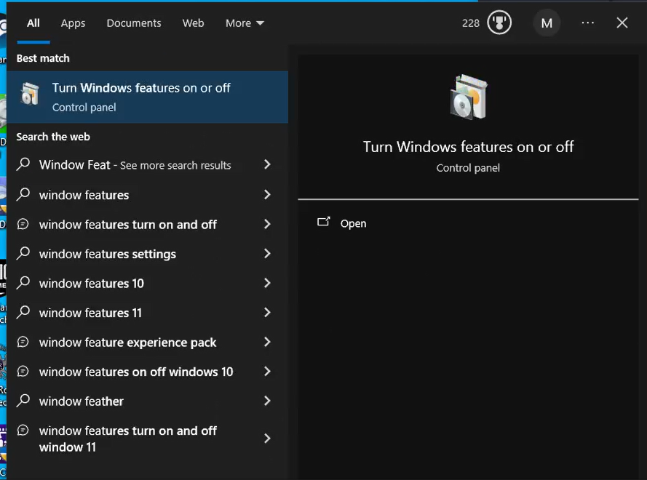

Step 2:Now scroll down click on Hyper-v **(“Don’t Click ok go to step no 3”).**

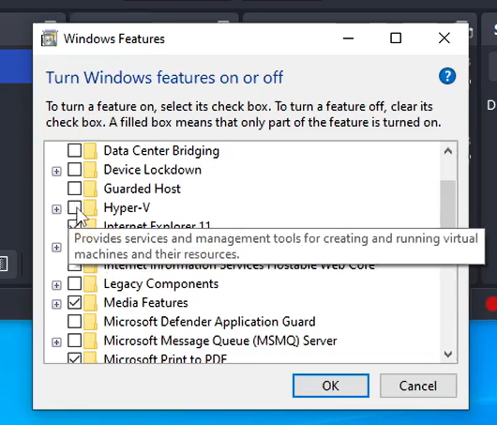

Step 3:Now scroll down click on Windows Sandbox and then click on ok

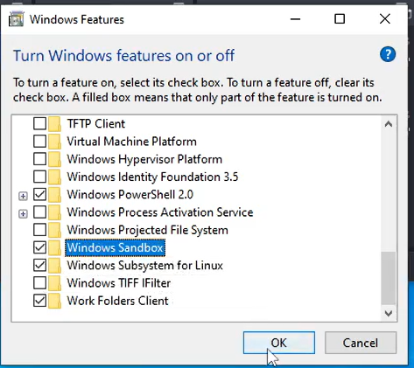

Step 4: Now Click on Restart Now (Pc will restart automatically and it will take few minutes for the setup.)

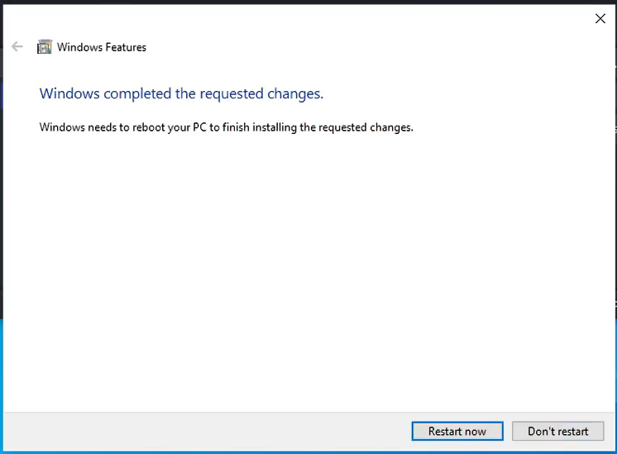

Step 5 : Now in Start Search for Hyper V-manager and open it.



Step 6 : Now click on the new-> Virtual Machine (Located on the right hand side of the tab) to create a virtual machine.

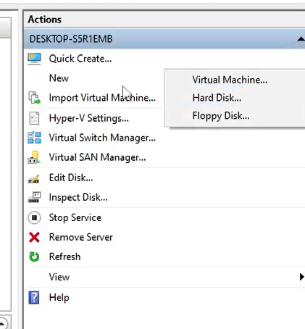

Step 7 : Press next and then assign the name for virtual machine and click on next.

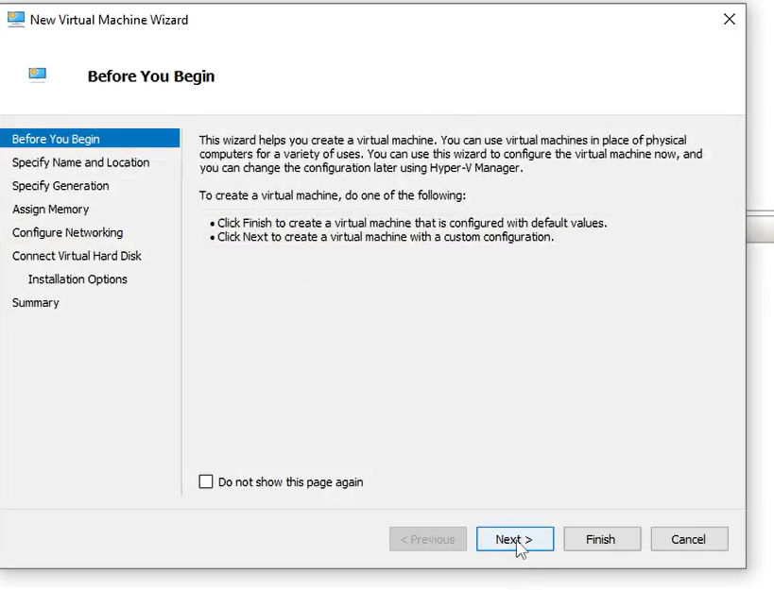 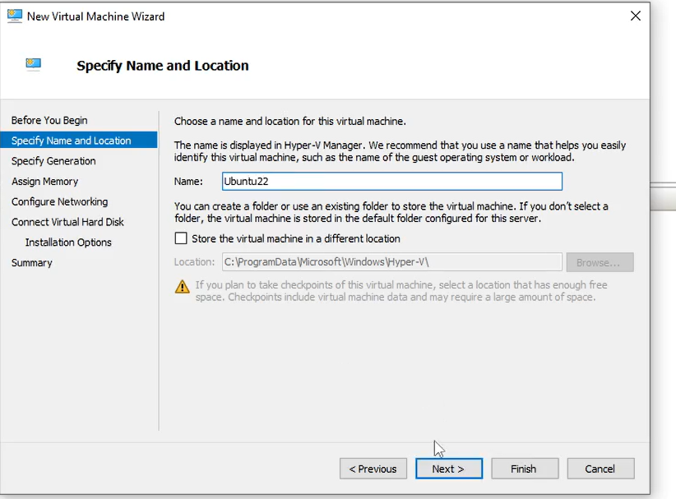

Step 8 : Now in the next assign memory(RAM ) 2048 or 4096 MB and click on next

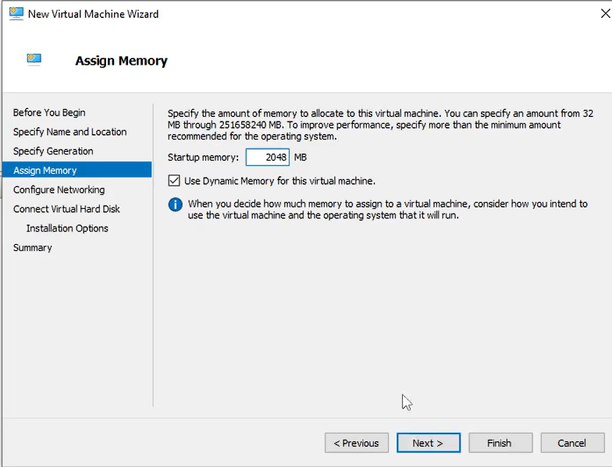

Step 9 : Now in the Configure networking section select Default switch and click on next.

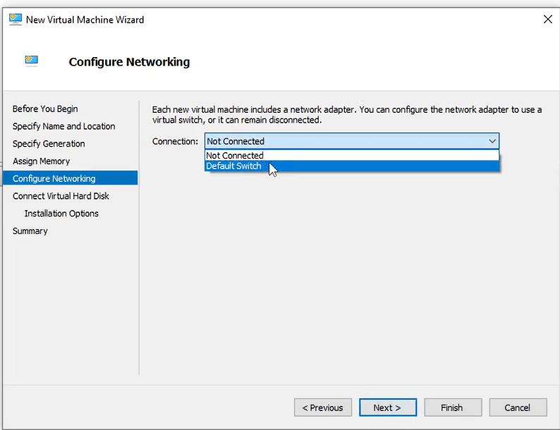

Step 10 : Now in Connect Virtual Hard Disk Section select the location where you want to save the VM file And now increase of memory to 140GB and click on next (Note:select the drive which have atleast 140 GB free .)

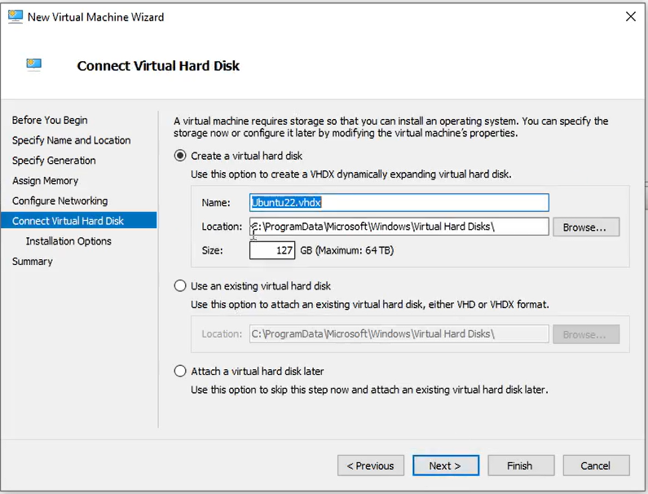

Step 11 : Now in Installation Option section Select “Install an operating system from cd/DVD-ROM” ,

Then Click on Image file -> Browse.. and select the Ubuntu Iso file and click on next.

(This file in the TYCS_CC_SOFTWARE folder check in Lab 1-1 )

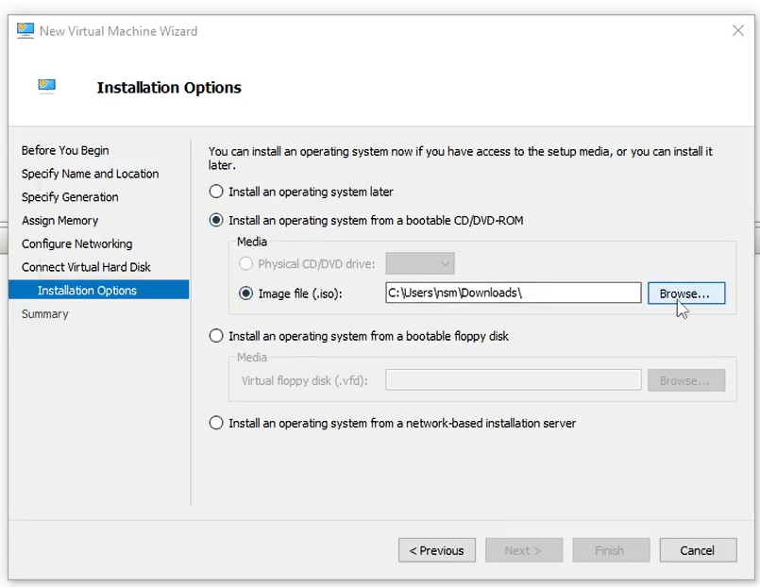 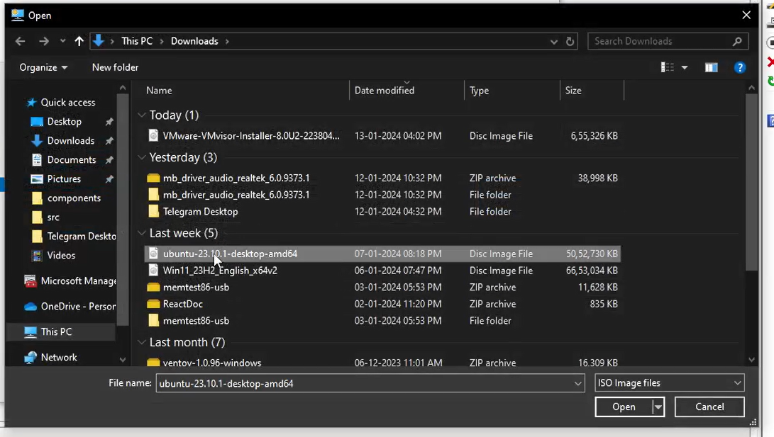

Step 12 : Now click on the finish Now the Vm is created

Step 13 : Now click on “Connect” located Right Handside in the Action (under the name of virtual machine which you have given.)

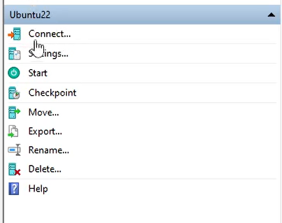

Step 14 : Now click on start.

Step 15 : Now use arrow keys and select the try or install ubuntu and press enter.

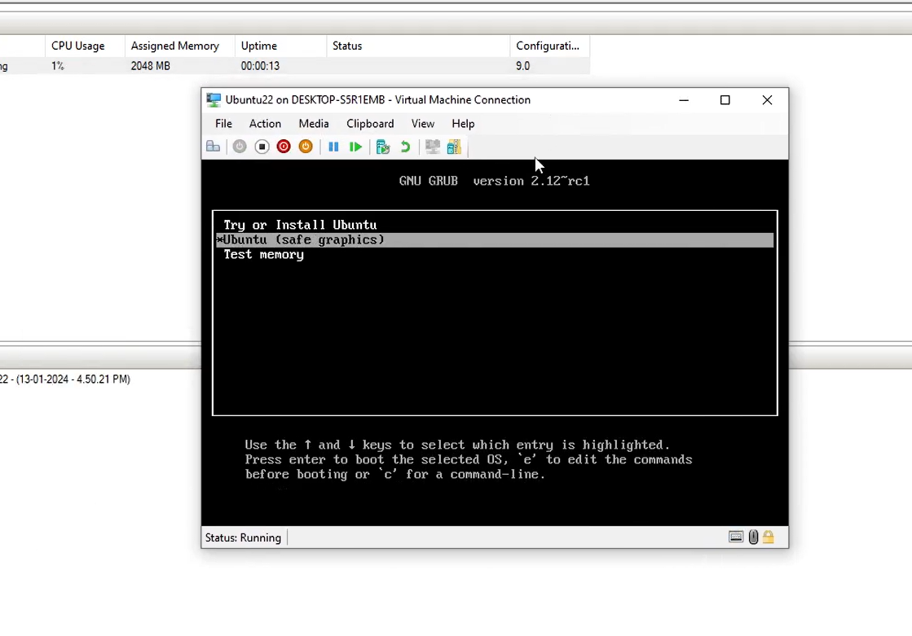

Step 16 : And now wait for the ubuntu to complete its installation.

Step 17 : Now open the terminal and execute the below commands in it.